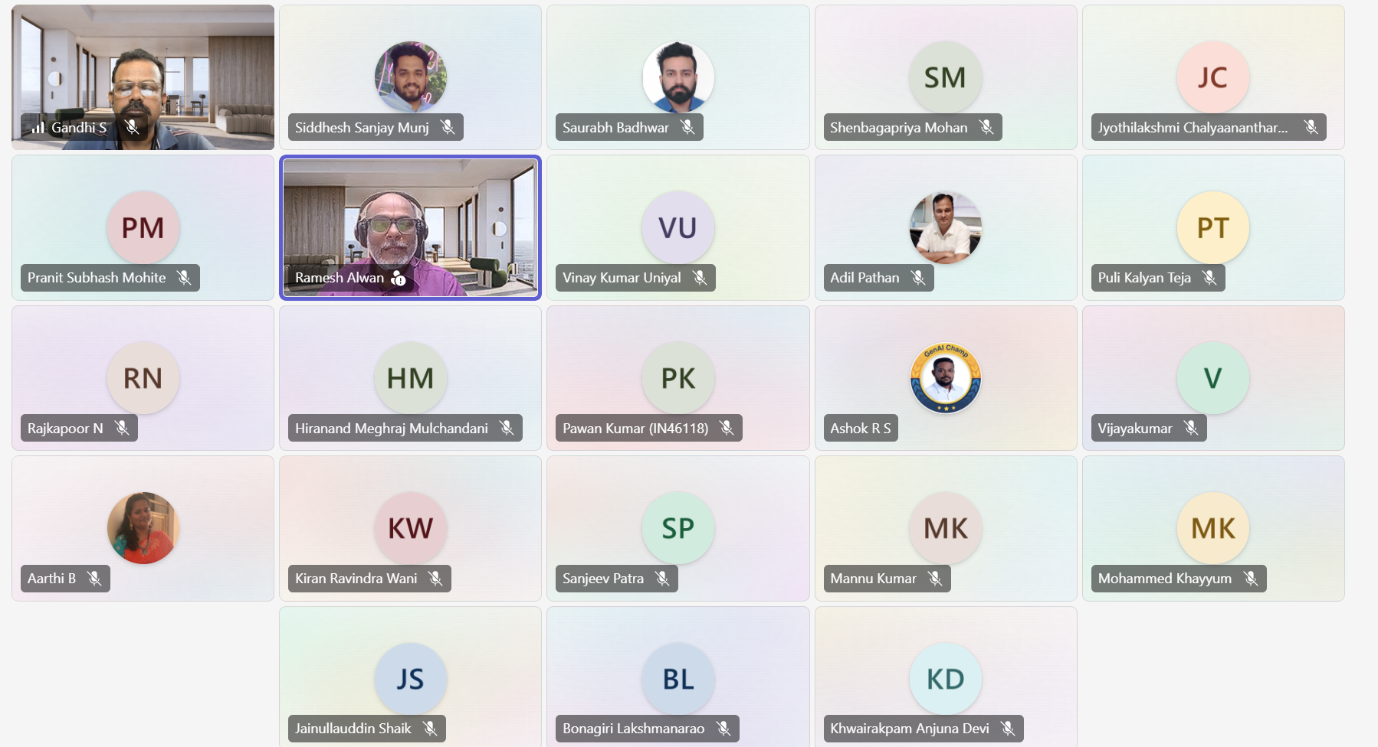
DevSecOps Practitioner Training
Module 1:
Day 1: 06/03/2026 Friday
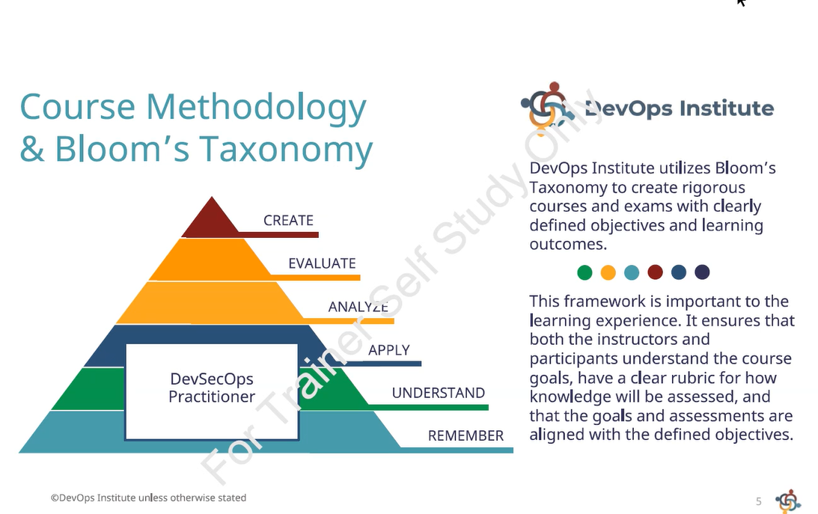
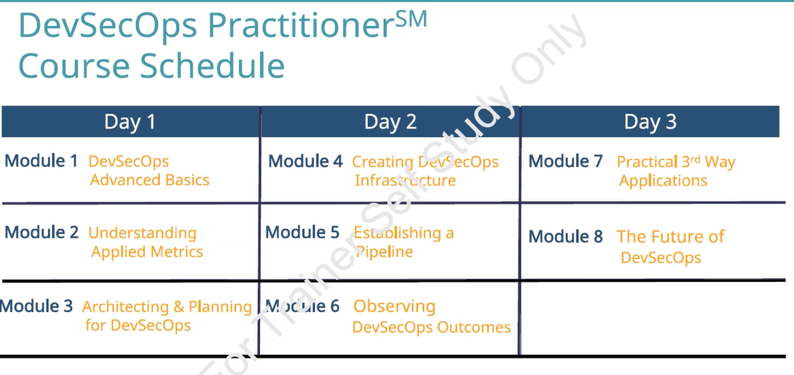
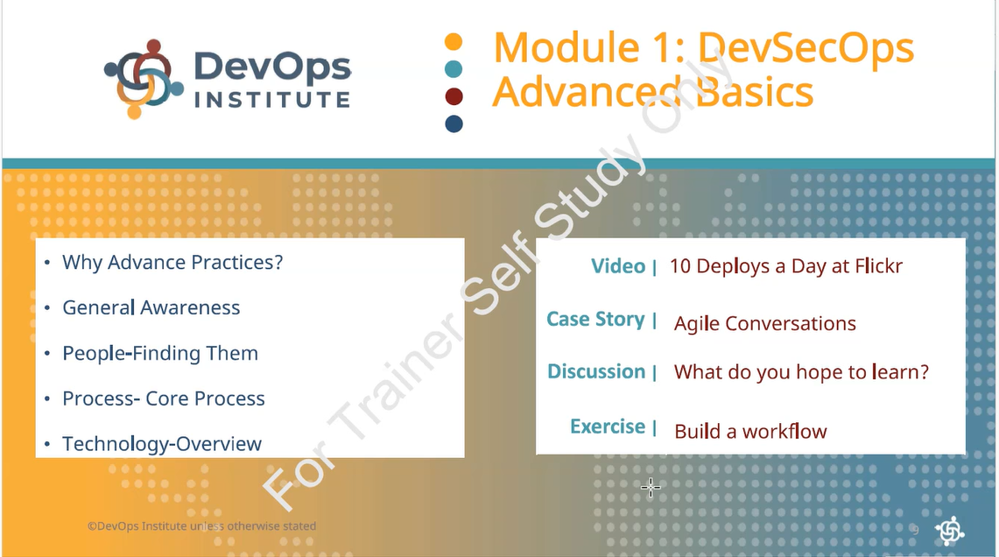
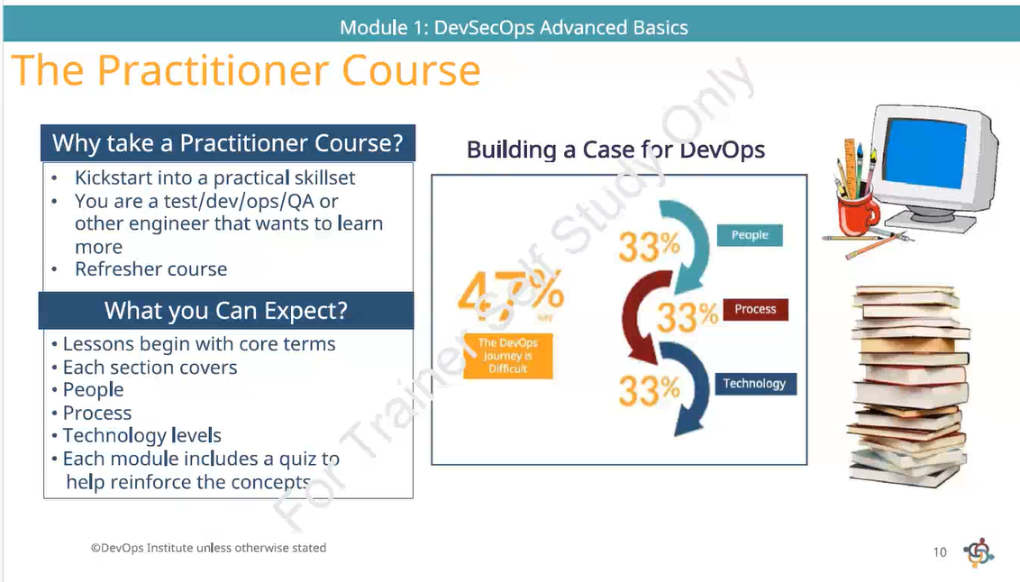
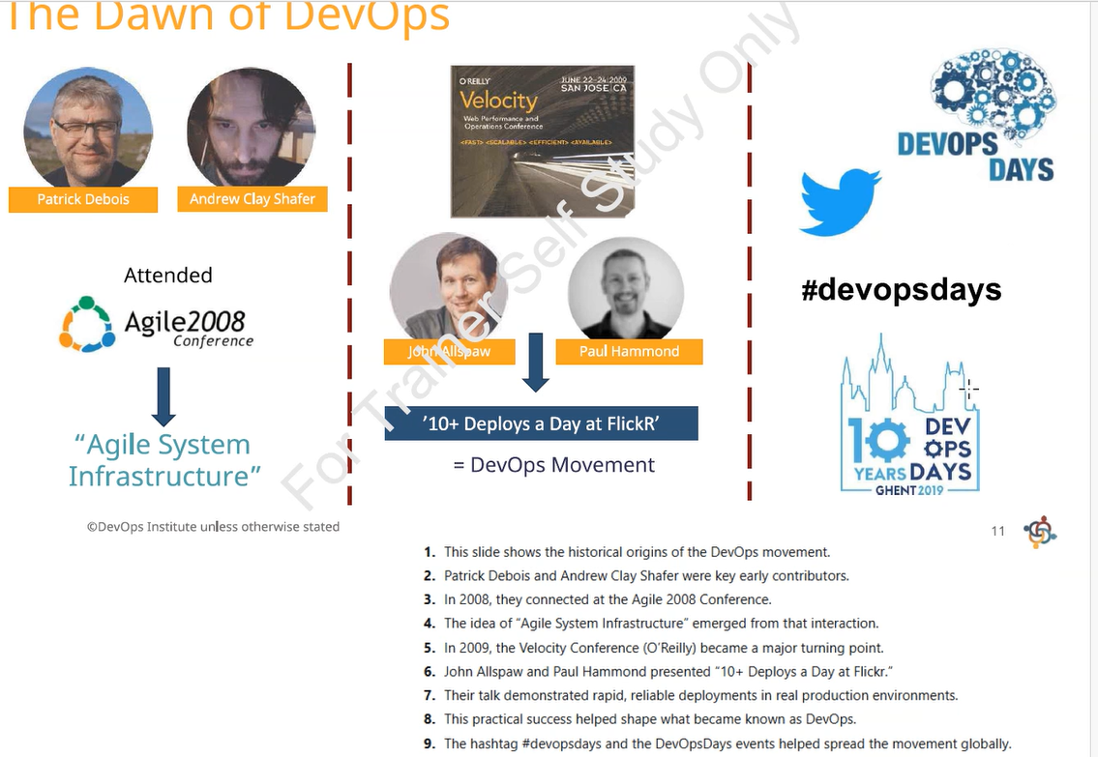
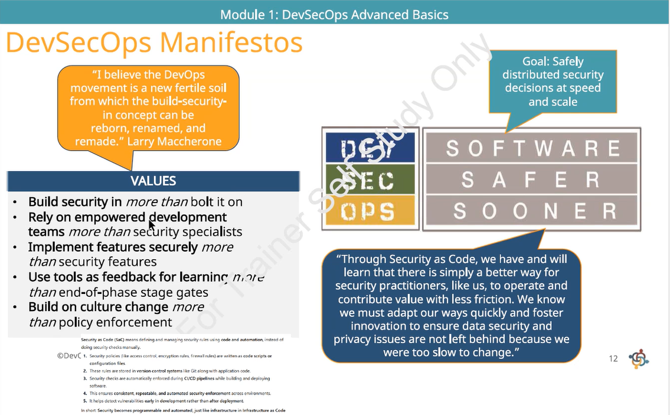
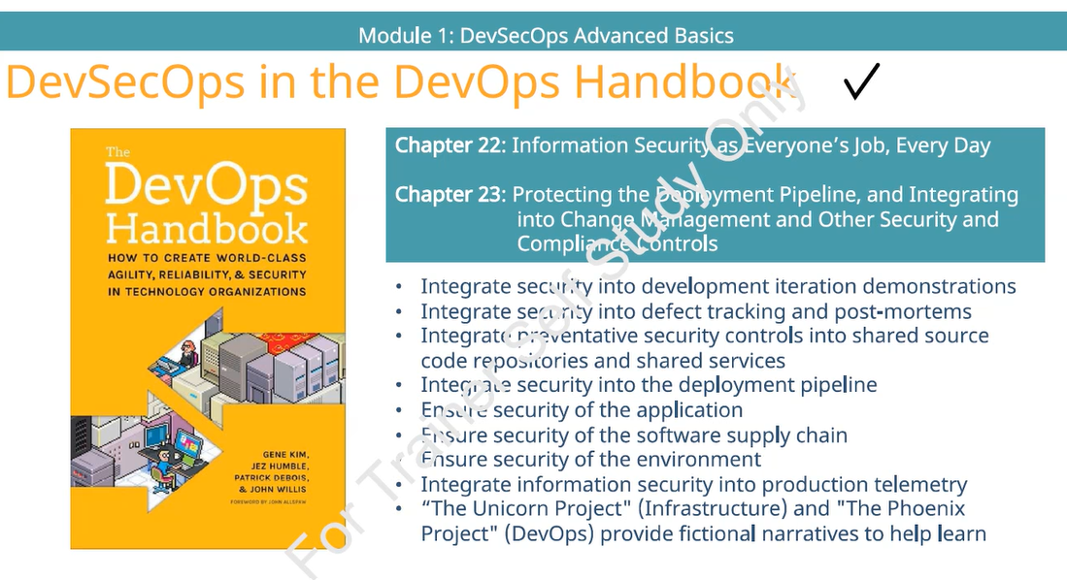
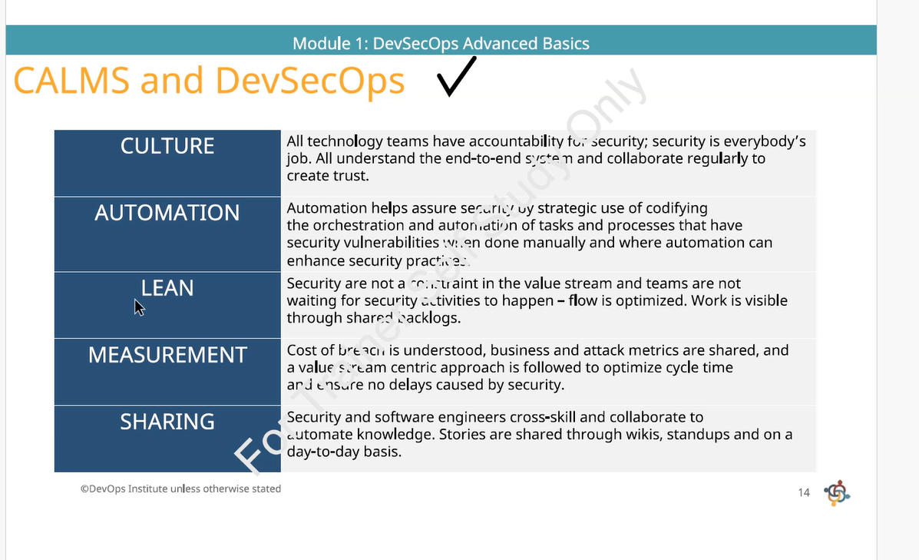
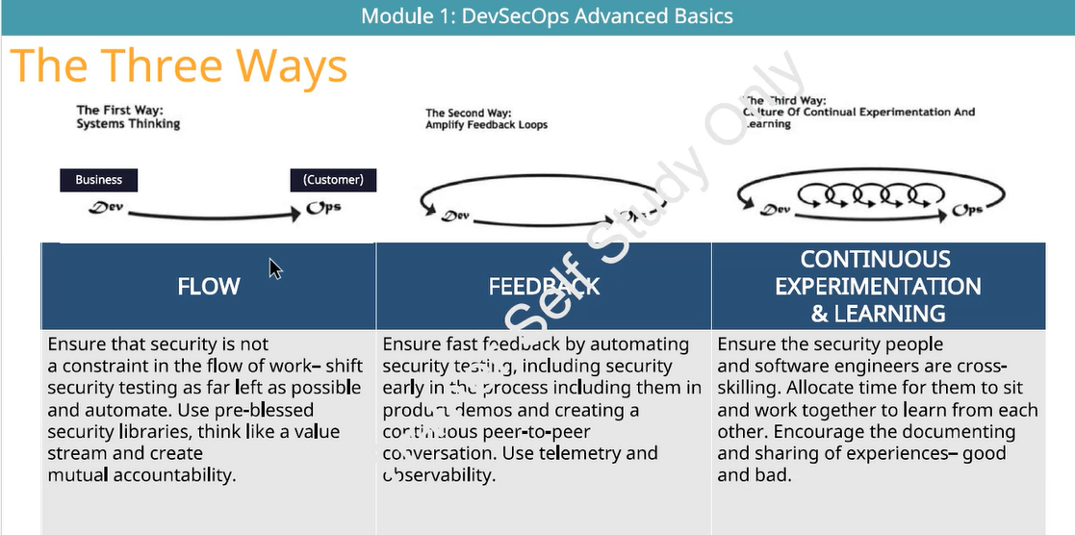
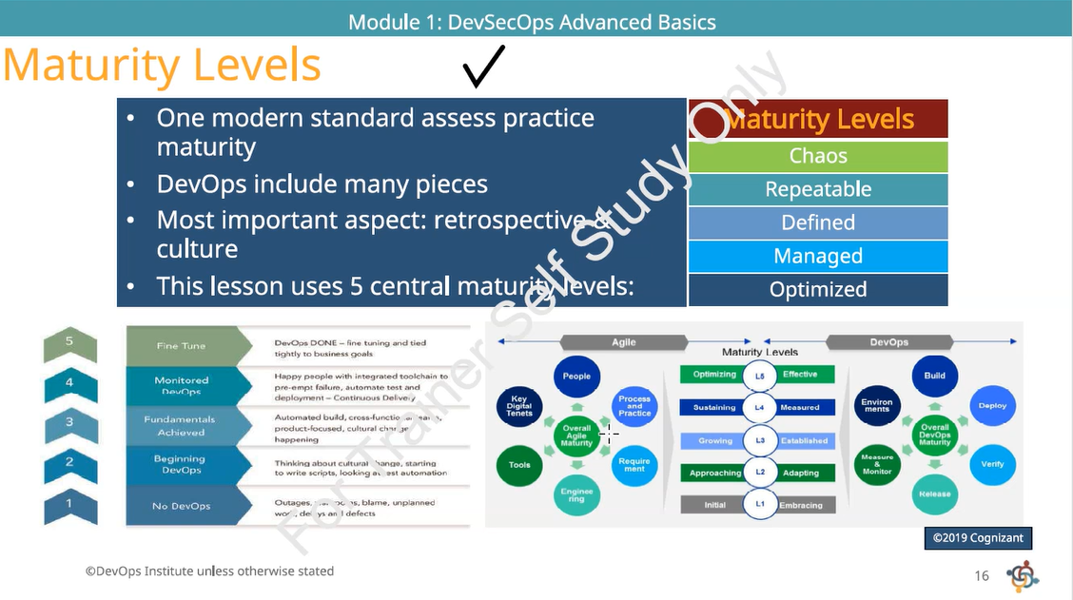
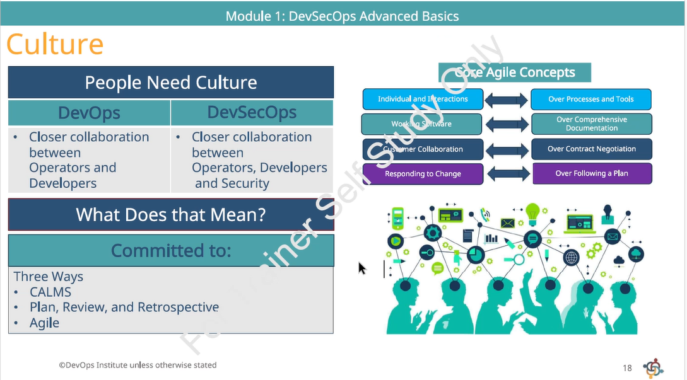
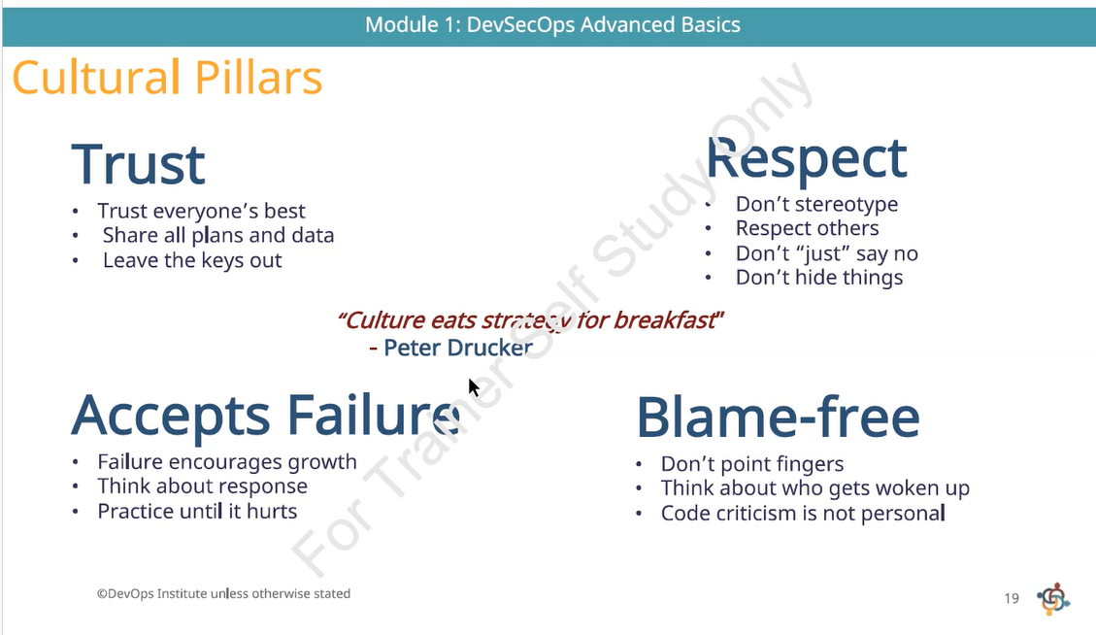
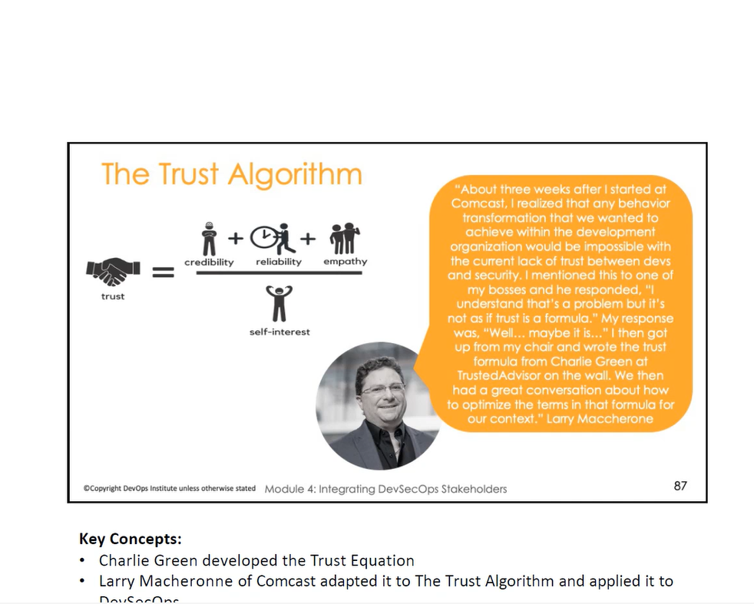
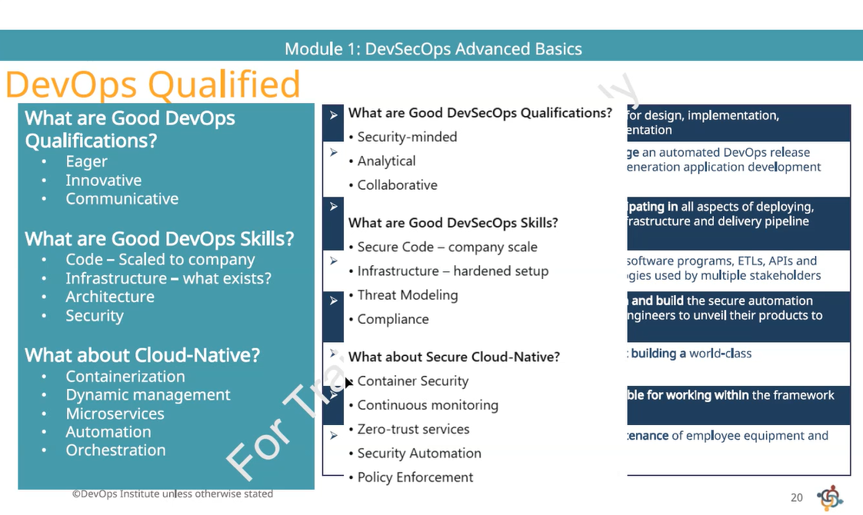
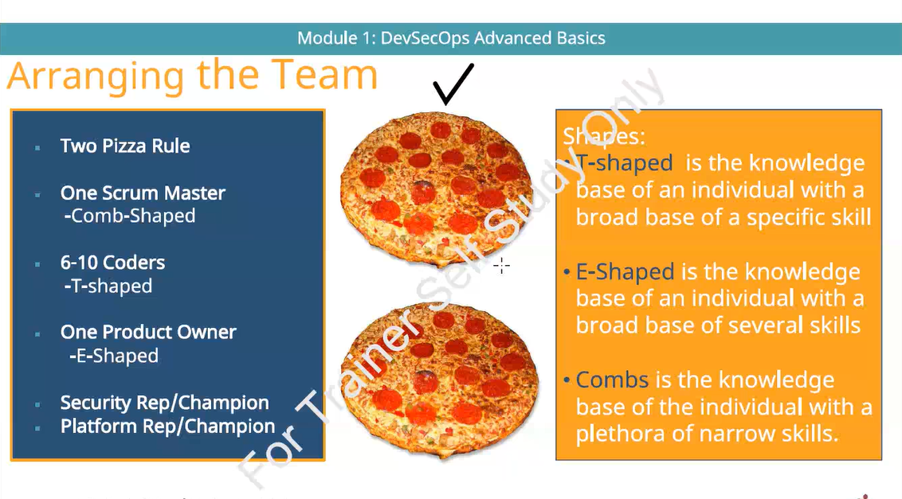
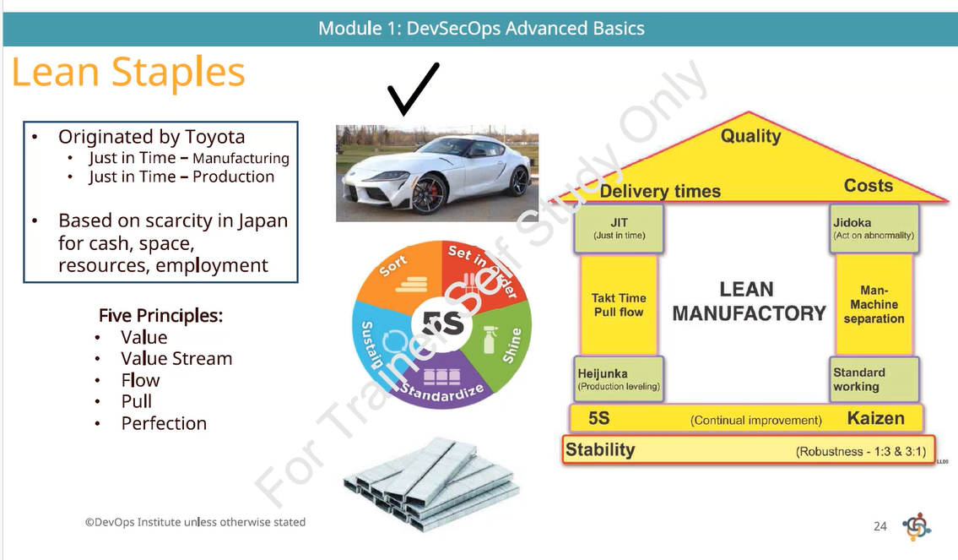
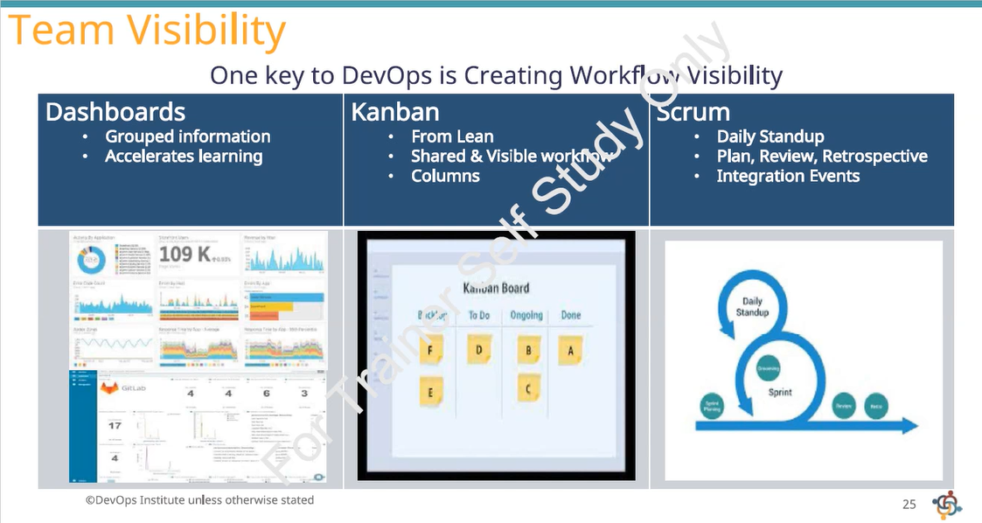
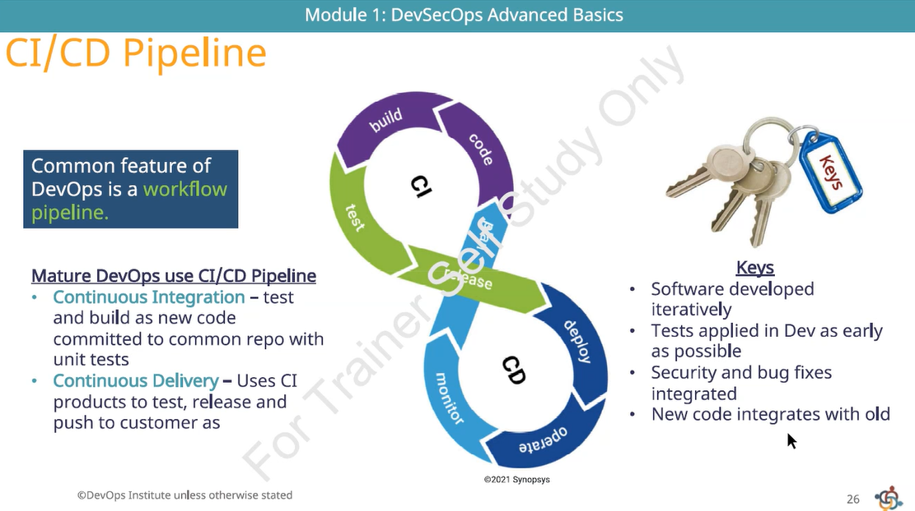
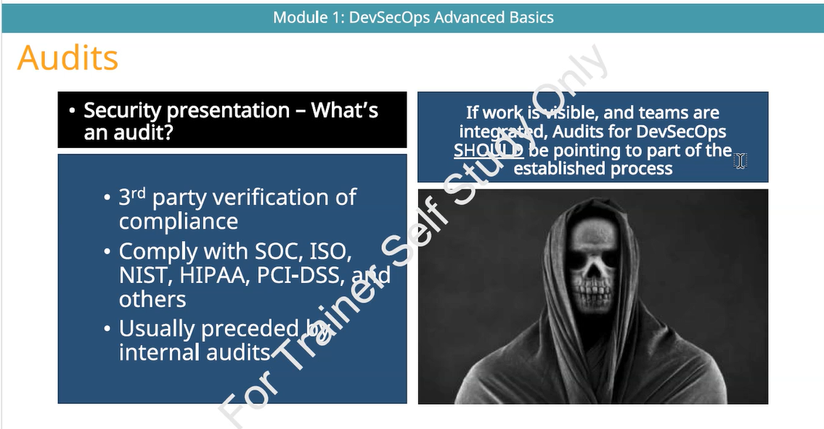
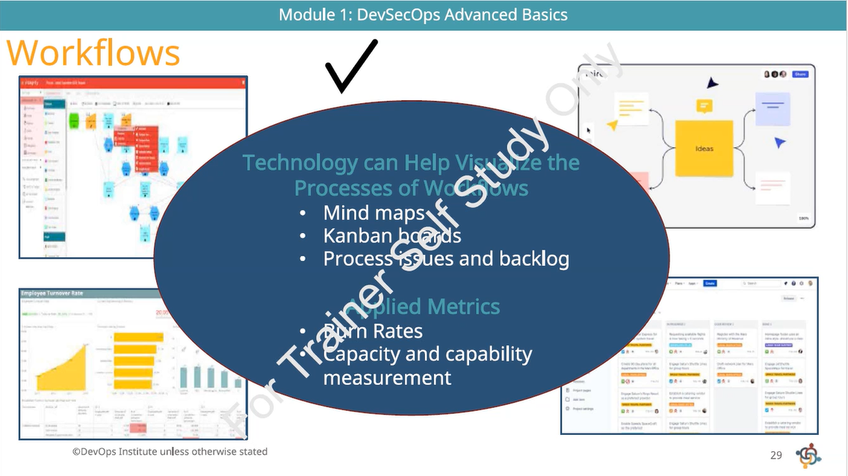
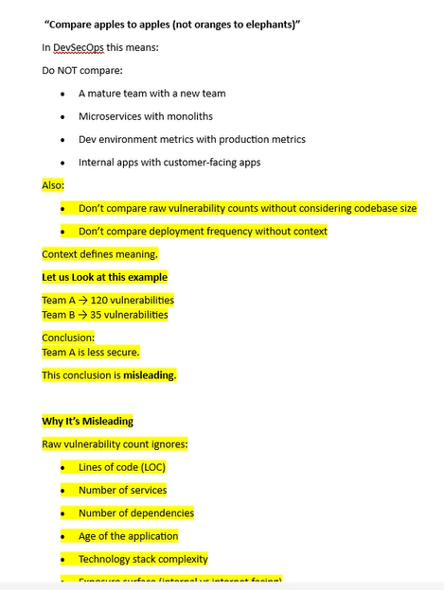
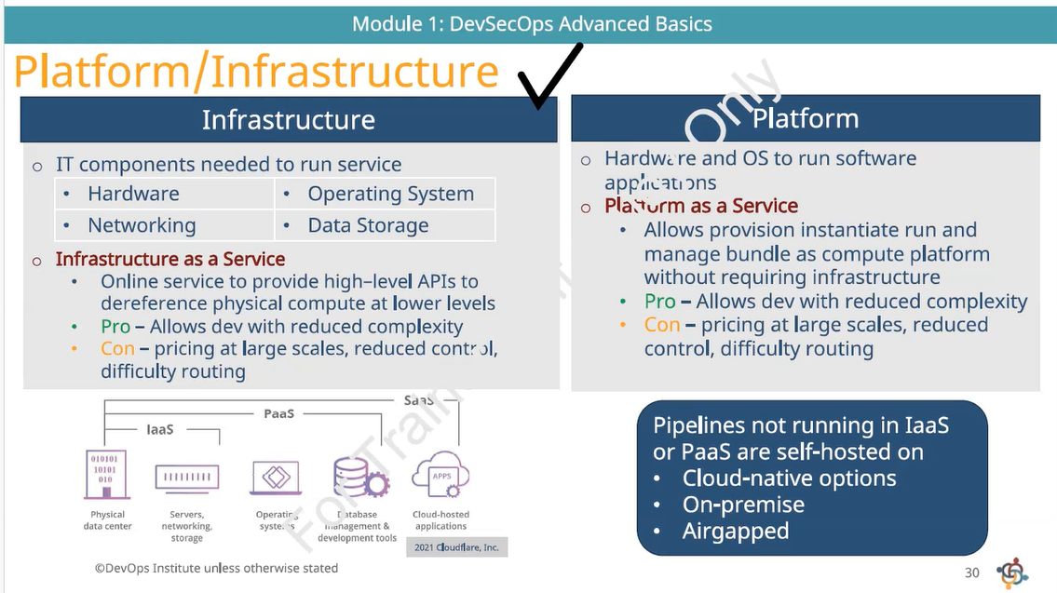
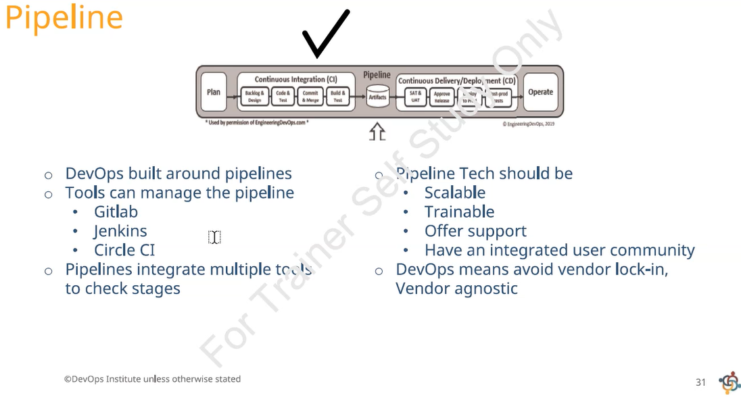
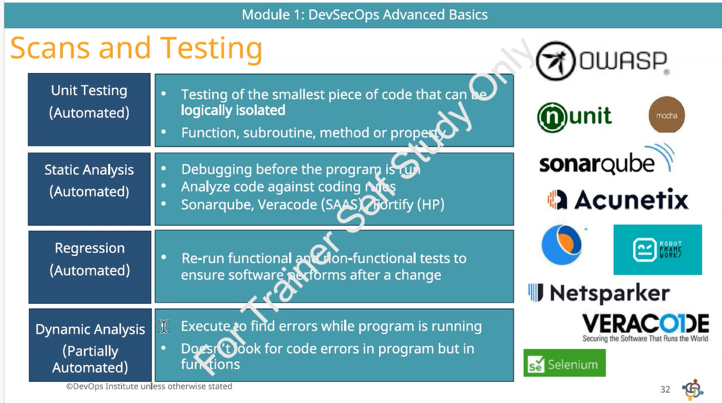
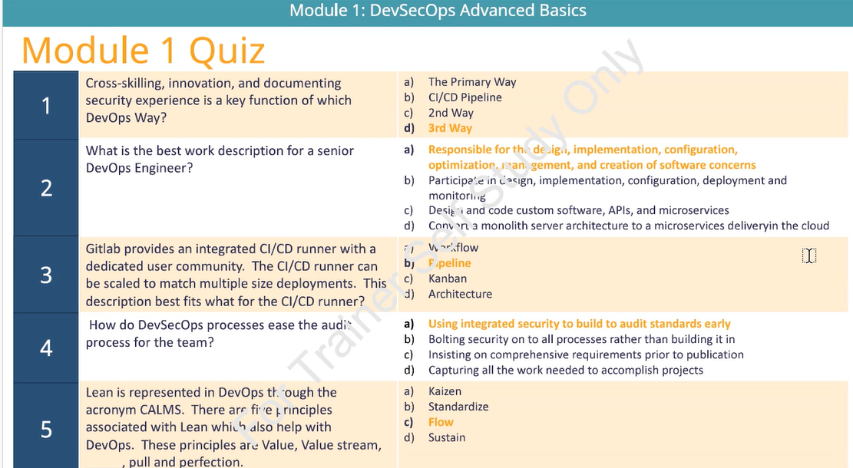

Meeting notes
Foundational Concepts of Security and Compliance: Ramesh Alwan led an interactive discussion with participants including Puli, Gandhi, Vijayakumar, Saurabh, Mohammed, Kiran, Hiranand, Ashok, and others to clarify the definitions and practical implications of security and compliance, linking them to regulatory frameworks and organisational practices.
.
Defining Security: Ramesh Alwan prompted the group to define security, eliciting responses such as protecting environments, preventing unauthorised access, implementing proper access controls, searching for vulnerabilities, and ensuring authentication and authorisation. The discussion highlighted the breadth of security, including Identity Access Management and threat modelling.
.
Understanding Compliance: Participants, guided by Ramesh Alwan, described compliance as adhering to organisational and regulatory policies, following best practices, and meeting required standards and regulations. Hiranand and others contributed examples such as configuration compliance and the importance of meeting standards set by regulatory bodies like HIPAA, SOX, and GDPR.
.
Relationship Between Security and Compliance: Ramesh Alwan explained that compliance is the act of meeting expectations, which may be requirements or mandates, and that security and compliance are closely linked, especially in technology-driven environments. He emphasised that compliance applies to security, business, and technology rules, and that meeting these is essential for organisational integrity.
.
Regulatory Frameworks in Practice: The group discussed real-world regulatory frameworks, with Ramesh Alwan referencing HIPAA for healthcare, SOX for financial controls, and GDPR as a global data protection framework. He clarified that compliance involves adhering to the specific requirements of these frameworks, which may be sector-specific or cross-industry.
Integration of Security in the Software Development Lifecycle (SDLC): Ramesh Alwan, with active participation from Puli, Gandhi, Aarthi, Mohammed, Vijayakumar, and others, explored the necessity of embedding security throughout the SDLC, advocating for early and continuous security involvement rather than post-development intervention.
DevSecOps Principles, Culture, and Team Structure: Ramesh Alwan facilitated a comprehensive examination of DevSecOps principles, the importance of a collaborative culture, and the structuring of teams to ensure security is a shared responsibility, with contributions from Gandhi, Puli, Kiran, Adil, and others.
.
DevSecOps Manifesto and Values: Gandhi read out the DevSecOps manifesto, which prioritises building security in from the start, empowering development teams, implementing features securely, using tools for iterative feedback, and fostering cultural change over policy enforcement. Ramesh Alwan elaborated on each value, stressing the need for cross-training and accountability among developers.
.
Security as Code and Automation: The discussion covered the concept of 'security as code', where security rules and controls are defined and enforced programmatically, similar to infrastructure as code. Ramesh Alwan explained that automation reduces manual errors, ensures consistency, and enables scalable, repeatable security enforcement in CI/CD pipelines.
.
Team Composition and Skills: Ramesh Alwan described optimal team structures using the two-pizza rule and skill shapes (T-shaped, E-shaped, comb-shaped), recommending small, cross-functional teams with dedicated security champions. He highlighted the need for developers, architects, business analysts, testers, product owners, SREs, and platform specialists to collaborate from the outset.
.
Cultural Pillars: Trust, Respect, and Blame-Free Environment: The group discussed the importance of trust (using a formula involving credibility, reliability, empathy, and self-interest), accepting failure as normal, respecting skills, and maintaining a blame-free culture. Ramesh Alwan introduced the zero trust principle, advocating for validation of all components and actions regardless of source.
Applied Metrics, Measurement, and Continuous Improvement: Ramesh Alwan, with input from Saurabh, Jyothilakshmi, Gandhi, and others, detailed the role of applied metrics in DevSecOps, covering measurement techniques, value streams, DORA metrics, and the use of metrics for continuous improvement and risk management.
.
Importance of Measurement: The team discussed the necessity of measurement for understanding current status, identifying areas for improvement, and setting thresholds for action. Examples included processor utilisation, vulnerability counts, and the use of telemetry for remote monitoring.
.
DORA Metrics and Value Streams: Ramesh Alwan introduced DORA metrics—lead time to change, deployment frequency, mean time to recover, and change failure rate—as key indicators of DevSecOps maturity. He explained how these metrics relate to value streams, which map the end-to-end flow of value from ideation to delivery.
.
Contextualising and Interpreting Metrics: The group examined the importance of context in interpreting metrics, such as normalising vulnerability counts by codebase size and considering deployment frequency in relation to team structure and application complexity. Ramesh Alwan cautioned against comparing dissimilar metrics and emphasised the need for meaningful, actionable measurements.
.
Continuous Improvement and Lean Principles: Lean principles, including eliminating waste, optimising flow, and sustaining improvements, were discussed as essential for efficient DevSecOps practices. The group explored tools such as Kanban boards, control boundaries (UCL/LCL), and the use of Six Sigma concepts to monitor and enhance process performance.
Security Tooling, Automation, and Pipeline Integration: Ramesh Alwan and participants including Puli, Shenbagapriya, Bonagiri, Ashok, and others examined the integration of security tools and automated checks within CI/CD pipelines, focusing on practical steps, trigger points, and the handling of vulnerabilities.
.
Pipeline Structure and Security Integration: The group outlined the stages of a CI/CD pipeline, from code commit to deployment, and identified where security scans (SAST, DAST, secret scanning) should be integrated. They discussed the importance of defining trigger points for automated scans, such as after code commits, merges, or feature additions.
.
Handling Vulnerabilities and Pipeline Failures: Participants agreed that if security scans detect vulnerabilities, the pipeline should fail, prompting remediation before proceeding. This approach ensures that only secure, compliant code advances to production, reducing the risk of post-deployment incidents.
.
Documentation and Audit Readiness: Ramesh Alwan stressed the need for documented processes, standards, and runbooks to support audits and compliance checks. He explained that undocumented practices, even if effective, are considered non-compliant during audits.
.
Tool Selection and Support: The team discussed criteria for selecting pipeline tools, including scalability, trainability, and supportability. They referenced common tools such as GitLab, Jenkins, and CircleCI, and highlighted the need for tools to support automated security enforcement.
Incident Management, Root Cause Analysis, and Remediation: Ramesh Alwan, with contributions from Saurabh, Jyothilakshmi, Ashok, and others, addressed incident management processes, the distinction between functional and security incidents, and the application of root cause analysis and remediation strategies.
.
Incident Causes and Types: The group identified various causes of incidents, including buggy code, configuration mismatches, infrastructure failures, and security breaches such as attacks or vulnerabilities. Ramesh Alwan clarified that while the handling of functional and security incidents may differ, both require systematic management.
.
Root Cause Analysis Techniques: Techniques such as postmortems, Ishikawa (fishbone) diagrams, and observability tools were discussed for identifying the underlying causes of failures. The importance of addressing both immediate and systemic issues was emphasised.
.
Remediation and Continuous Improvement: Participants discussed the need for prompt remediation of vulnerabilities and the tracking of hotfixes and change failure rates. Ramesh Alwan highlighted the evolution from manual to automated processes, which has reduced change failure rates over time.
Practical Exercises and Study Materials: Ramesh Alwan coordinated the distribution of a DevSecOps workflow exercise and addressed questions about study materials, with Gandhi, Kiran, and others assisting in sharing resources and managing group activities.
.
DevSecOps Workflow Exercise: Participants were assigned an exercise to design a DevSecOps workflow for a banking application, considering security controls, compliance requirements, pipeline integration, and incident response. Ramesh Alwan provided the scenario and facilitated group formation for collaborative work.
.
Study Material Distribution: Ramesh Alwan explained the availability of official training materials and his own supplementary notes, offering to share additional content for specific slides upon request. Gandhi assisted in collecting slide numbers and distributing materials to the group.
Are these notes useful?
Follow-up tasks
.
Distribution of DevSecOps Exercise Document: Send the DevSecOps workflow exercise document for the BFSI application to Gandhi for internal distribution to all participants. (Ramesh Alwan)
.
Provision of Additional Study Materials: Provide explanatory documents for slides 16, 20, 23, and 30 to Gandhi for further sharing with the team. (Ramesh Alwan)
.
Breakout Session Coordination: Coordinate with Thirumoorthi to resolve breakout room access for group exercises and ensure breakout sessions can be conducted as planned. (the team)
.
Study Material Access Clarification: Clarify with Thirumoorthi and Ramesh Alwan regarding access to PeopleCert study material for certification preparation. (Adil)

